Santhanakrishnan Ramani

SID: 105720585

**Assignment 3**

***Part 1***

function plotprobcont

hold off

models = 0:.001:1;

h = 0; t = 0;

ct = 1;

label = 'priors';

for outcome = [1 0 0 1 0 0 0 1 ]

subplot(2,4,ct)

**posterior = betapdf(models,h+1,t+1);**

hold off

plot(models, posterior);

hold on

title(label);

xlabel('model');

set(gca,'ylim',[0 3]);

h = h + outcome;

t = t + (1-outcome);

label = 'T';

if (outcome)

label = 'H';

end

label = sprintf('trial %d: %s',ct,label);

ct = ct + 1;

end

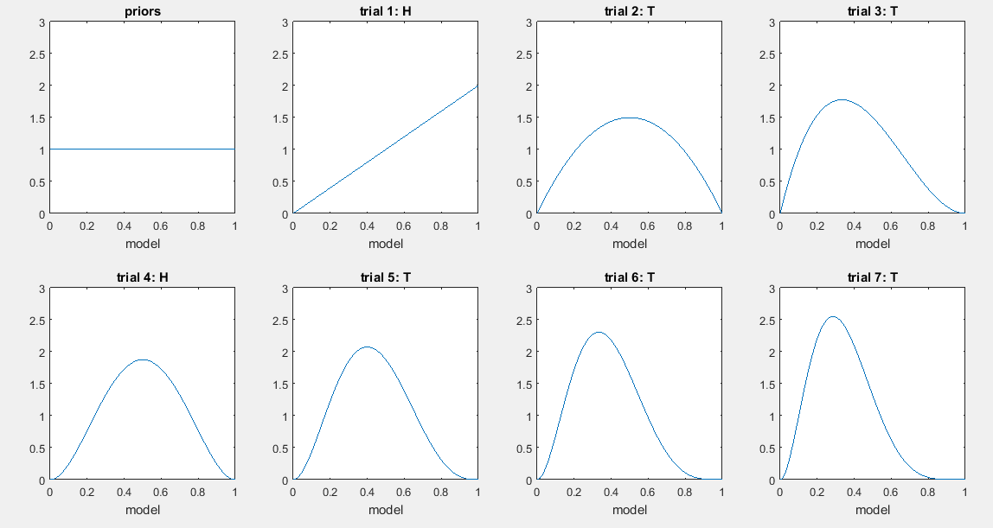

***Part 2***

Likelihood

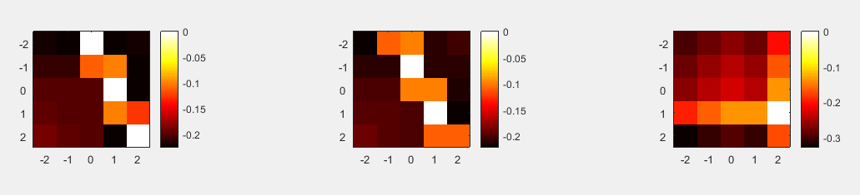

Posterior with Free Parameter = 0.01

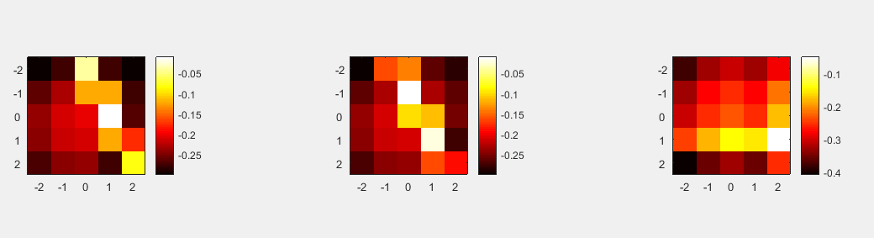

Posterior with Free Parameter = 0.15

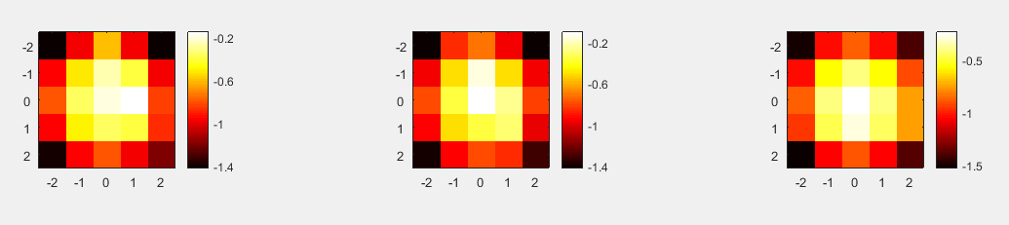

***Part 3***

|  |  |  |  |  |
| --- | --- | --- | --- | --- |
| ***(Rx=0.75, Ry=-0.6, Bx=1.4, By=-0.2)*** | ***Uniform Prior*** | | ***Prior of Down 5 times likely than other directions*** | |
|  | ***Task 1 (σ=1)*** | ***Task 2 (σ=5)*** | ***Task 3 (σ=1)*** | ***Task 4 (σ=5)*** |
| ***P(Direction=up|Rx,Ry,Bx,By)*** | ***0.0395*** | ***0.2416*** | ***0.0222*** | ***0.1190*** |
| ***P(Direction=down|Rx,Ry,Bx,By)*** | ***0.1956*** | ***0.2576*** | ***0.5487*** | ***0.6343*** |
| ***P(Direction=right|Rx,Ry,Bx,By)*** | ***0.7546*** | ***0.2719*** | ***0.4234*** | ***0.1339*** |
| ***P(Direction=left|Rx,Ry,Bx,By)*** | ***0.0102*** | ***0.2289*** | ***0.0057*** | ***0.1127*** |